PYTHON 程序设计

课程设计报告

文档类型： 一 个人

专业： 软件18 班级： 1

学号： 2018010160933

设计人： KAFLE SAMRAT

山 东 科 技 大 学

**Analog Wheel Game:**

Key Points:

(1) Master the method of using a function randint to generate a random number, master the use of variable assignment operations .  
(2) Master the use of if-lfelse conditional statements.

(3) Master the while loop, and master the combined application of conditional statements and loop statements.

(4) Master the functions of (GUI library of Python -) Tkinter.

Specifications:

Use Pandas to simulate the game and count the number of wins in each of the 10,000 games. Suppose that the range of [0, 0.08] corresponds to the first prize, [0.08, 0.3] corresponds to the second prize, and [0.3, 1] corresponds to the third prize after the turntable Angle normalization.

(使用pandas模拟转盘抽奖游戏，统计10000次游戏中各奖项的中奖次数。假设转盘角度归一化之后[0, 0.08]区间对应一等奖，[0.08, 0.3]对应二等奖，[0.3, 1]对应三等奖。)

code:

import tkinter

import numpy as np

import pandas as pd

import time

import threading

from random import *

**class** Roulette:

**def** setwindow(self):

self.btn_start = tkinter.Button(self.root, text = 'start/stop',command = self.newtask)

self.btn_start.place(x=115, y=125, width=65, height=50)

self.btn1 = tkinter.Button(self.root, text='Sam', bg='red')

self.btn1.place(x=20, y=20, width=50, height=50)

self.btn2 = tkinter.Button(self.root, text='Ram', bg='white')

self.btn2.place(x=90, y=20, width=50, height=50)

self.btn3 = tkinter.Button(self.root, text='Harry', bg='white')

self.btn3.place(x=160, y=20, width=50, height=50)

self.btn4 = tkinter.Button(self.root, text='Bini', bg='white')

self.btn4.place(x=230, y=20, width=50, height=50)

self.btn5 = tkinter.Button(self.root, text='Gita', bg='white')

self.btn5.place(x=230, y=90, width=50, height=50)

self.btn6 = tkinter.Button(self.root, text='Brita', bg='white')

self.btn6.place(x=230, y=160, width=50, height=50)

self.btn7 = tkinter.Button(self.root, text='Mike', bg='white')

self.btn7.place(x=230, y=230, width=50, height=50)

self.btn8 = tkinter.Button(self.root, text='Brinda', bg='white')

self.btn8.place(x=160, y=230, width=50, height=50)

self.btn9 = tkinter.Button(self.root, text='Dhoni', bg='white')

self.btn9.place(x=90, y=230, width=50, height=50)

self.btn10 = tkinter.Button(self.root, text='Jack', bg='white')

self.btn10.place(x=20, y=230, width=50, height=50)

self.btn11 = tkinter.Button(self.root, text='Kapil', bg='white')

self.btn11.place(x=20, y=160, width=50, height=50)

self.btn12 = tkinter.Button(self.root, text='Kafle', bg='white')

self.btn12.place(x=20, y=90, width=50, height=50)

self.WholeButtons = [self.btn1,self.btn2,self.btn3,self.btn4,self.btn5,self.btn6,self.btn7,self.btn8,self.btn9,self.btn10,self.btn11,self.btn12]

**def** __init__(self):

self.root = tkinter.Tk()

self.root.title('Analog Wheel Lottery Game')

self.root.minsize(300, 300)

self.isloop = False

self.newloop = False

self.setwindow()

self.root.mainloop()

**def** rounds(self):

if self.isloop == True:

return

i = 0

while True:

if self.newloop == True:

self.newloop = False

return

time.sleep(0.1)

for x in self.WholeButtons:

x['bg'] = 'white'

self.WholeButtons[i]['bg'] = 'purple'

i += 1

if i >= len(self.WholeButtons):

i = 0

**def** newtask(self):

if self.isloop == False:

t = threading.Thread(target = self.rounds)

t.start()

self.isloop = True

elif self.isloop == True:

self.isloop = False

self.newloop = True

c = Roulette()

data = np.random.rand (10000)

Category = (0.0,0.08,0.3,1.0)

labels = ('一等奖','二等奖','三等奖')

result = pd.cut (data,Category,labels=labels)

result = pd.value_counts(result)

print(result)

Result:

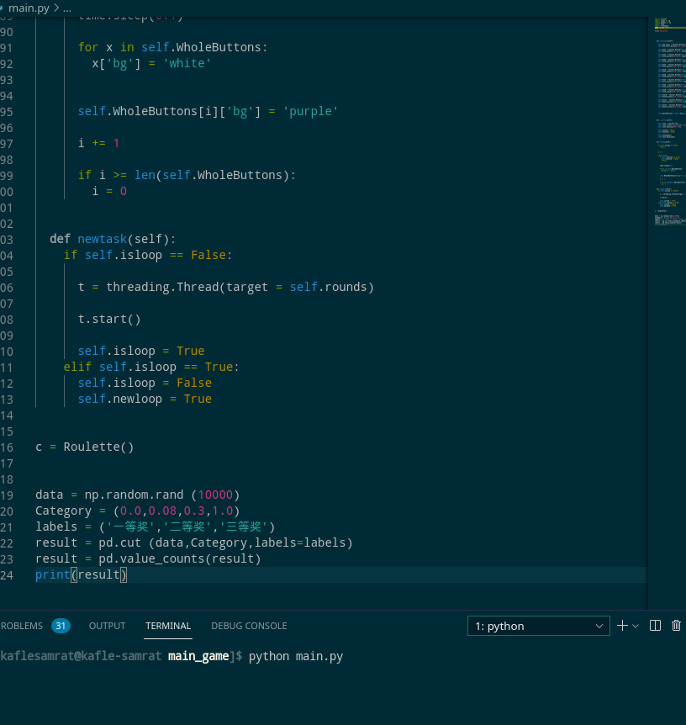.

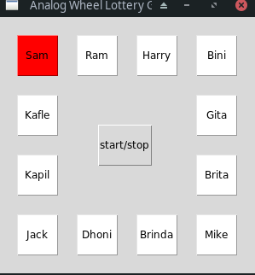.

First :

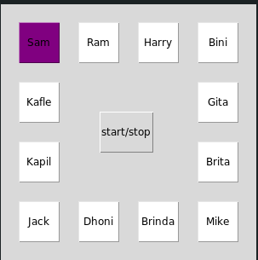

.

Second:

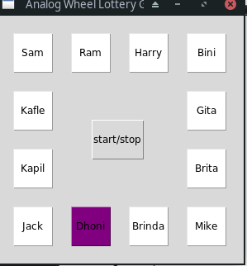.

Third:



